 Sec 3.1 – Statistical Studies

Definitions Name:

**1. POPULATION:**

**Parameter**  [Greek variables] **:**

1. **SAMPLE:**

**Statistic** [English variables] **:**

**3.** List reasons why you might use a **SAMPLE** study instead of a **POPULATION** study?

**4.** A recent survey by the alumni of a major university indicated that the average salary of 8,500 of its 250,000 graduates was $123,000. Does this value describe a parameter or a statistic? WHY?

**5.** A survey of 976 American households found that 32% of the households own two cars. Identify the population and the sample.

SAMPLE:

POULATION:

***For # 6– 8 Identify each of the following data sets as either: (P) Population or (S) Sample***

1. ….the age of a few randomly selected participants in a study about a race of runners
2. ….the annual salary of each full-time teacher in a study about Phoenix High School
3. ….a survey of 750 Georgia homeowners in a study about all of Georgia’s homeowners.

***For # 9 – 11 Identify each of the following numerical values as either: (P) Parameter or (S) Statistic***

1. …. of a company’s employees the opinion of just those that were there on time one morning about what they thought of a new training program.
2. …. in a study about a small company of 25 employees, the range of their employee’s salaries
3. …. in a study about the value of American homes in 2012, the average decrease of all the homes sold in Gwinnett.

*AMDM Student Worksheets Created By Matthew M. Winking at Phoenix High School SECTION 3-1*

*p.32*

**TYPES OF SAMPLES**

**12. Simple Random sample:**

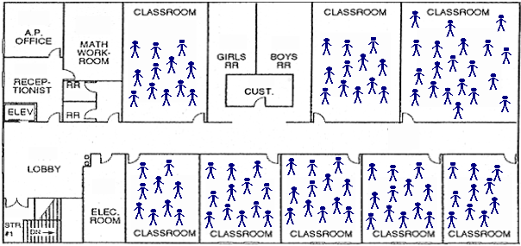

**13. Stratified sample:**

**14. Cluster sample:**

**15. Systematic sample:**



**16. Convenience sample:**

**Choose which sampling technique is used.**

**(R) Random (STR) Stratified (CLS) Cluster (CON) Convenience (SYS) Systematic**

_______ 17. There are 250 seventh graders and 300 eighth graders at Generic Middle School. We ask 45 seventh graders and 50 eighth graders how many siblings they have to compare the two groups.

_______ 18. I ask all freshmen, no sophomores, no juniors, and all seniors if they prefer Vanilla or Cherry Coke (these four groups are my only four groups) to create a study of what should be in the vending machines.

_______ 19. I ask everyone in my 5th period class who has more than one computer at home in a study about all of my students for the year.

_______ 20. I collect data from every 15th student on my list of the entire school population.

_______ 21. After using a random number table to generate two-digit numbers, I decide on 10 people to choose from the population.

**Rank the sampling types in order from what would usually be the WORST to BEST representation of a POPULATION. Provide brief explanations (especially if the ranking depends on the study).**

**(R) Random (STR) Stratified (CLS) Cluster (CON) Convenience (SYS) Systematic**

*AMDM Student Worksheets Created By Matthew M. Winking at Phoenix High School SECTION 3-1*

*p.33*